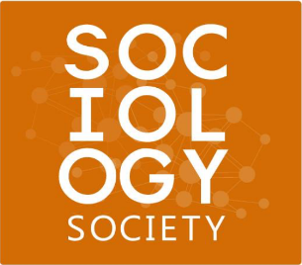
Academic Executive Application
Sociology Society

About the Sociology Society
We are a student-governed community, supervised by the Department of Sociology and Legal Studies. Focused around student interests, we provide opportunities for students to become familiar with their program and faculty members outside the classroom. In effort to bring sociology students together and create a sense of unity, we offer support with academic resources, advice, and events. We are dedicated to making and achieving goals to enhance your overall undergraduate experience!

If you consider yourself to be a leader, reliable, outgoing, committed, and creative, you are invited to apply for the following position:

Academic Executive

Responsibilities:
- Plan at least one academic event per term.
- Share ideas and events with academic relevance with the Society.
- Run the Sociology Society Library, housed in the Sociology Society Office. Tasks can include, but are not limited to, scheduling office hours, collecting new books, following up on missing books etc.
- Coordinate and oversee volunteer compliance during academic events.
- Ensure student comments or complaints about courses and academic plans in sociology are being communicated effectively to the department chair, or appropriate contact.
Qualifications:
- Be enrolled as a current Waterloo undergraduate student.
- Be enrolled in a major or minor under the Legal Studies & Sociology department.
- Be interested in providing students with the resources they need and enhancing the overall student experience.
- Previous experience with event planning an asset.
Application:
Why are you applying for the role of Academic Executive for the Sociology Society?
If you had the opportunity to plan an academic event for sociology students, what would it be?
Please circle your availability for the 2016/2017 academic year.
Fall 2016: On Campus Off Campus Winter 2017: On Campus Off Campus

Interested candidates may submit completed applications to uwsocsociety@gmail.com with the subject, Academic Executive Application 2016/2017.

