What would a seventy year-old woman bring? | What would a sixty-seven year-old man bring?
What would a seven year-old boy bring? | What would a fifteen year-old girl bring?
What would a ten year-old girl bring? | What would a fourteen year-old boy bring?
What would an adult man bring? | What would an adult woman bring?

Big Question today: What do you value? What is important to your life, to your survival?
When you pack to go on a trip, you bring the things you think you’ll need: clothes, grooming items, camera, etc. Usually you are going because you want to go, and you know how long it will be.
During WWII, despite being Canadian citizens, Japanese Canadians were forced out of their homes, they didn’t know how long it would be and they hadn’t really heard of the places where they were sent.
Show pictures of JCs 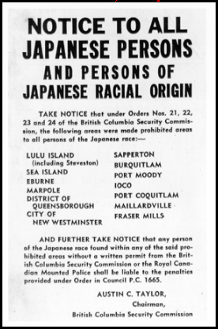 being shipped out.
Teams of 3, 4, or 5.
get random characters
work together to get consensus
could bring one suitcase, and they had to be able to carry it
There were no TVs, personal computers, cell phones, nor tablets back then. Radios, cameras and recording devices were confiscated.
You don’t know how long you are going.
You could be sent to the interior of BC or the prairies.
Journal: What would YOU bring today if you were interned?
Share lists.
Share suitcase from JCNM

